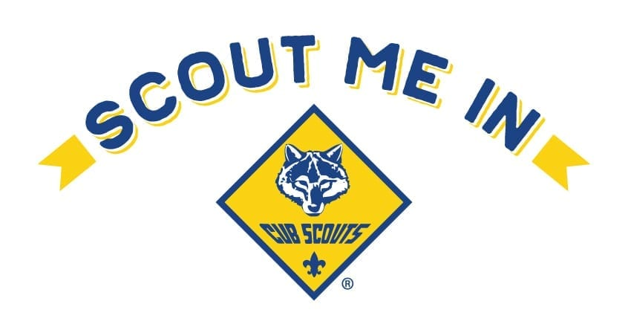

2020-2021 DUES - PACK 3169

NEW SCOUTS:
Sept 1 - Dec 31 2020
Joining Fee (this is a one-time fee) $25
Nat’l Fee $5.50 / month x 4 months $22
Scout’s Life $1 / month x 4 months $4

Total due when signing up $51

RETURNING SCOUTS:
Jan 1 - Dec 31 2021
National Fee $66
Scout’s Life Magazine $12
Pack Fee (insignia, activities, supplies) $100

Total due by Dec 15, 2020 $178

Sell $534 in popcorn to cover your year of Scouting

What do my Pack Dues cover?
18 % Scout Insignia/Awards 29% Camping Trips
43% Special Events (pwd, B&G) 10% Leadership Training

How much do I pay?
- First time Scouts – Pay $51 for remainder of BSA dues ($5.50 for each month Sept – Dec 2020)
Immediately when joining, as well as purchase a uniform and book
- All Scouts – At the end of popcorn sales (October), each Scout must pay $178 BSA and Pack dues for the next year

We NEVER want money to hold a child back who wants to participate in Scouting. If you have concerns about costs, PLEASE speak to any member of the leadership team (adults in tan shirts). Payment plans are available

Committee Chair kurt.westover@gmail.com
Cubmaster Jacob.aukeman@gmail.com
Treasurer marisanitz76@gmail.com
Welcome to Pack 3169. The following is intended to explain the costs of participating in our Cub Scout Pack. There are mostly annual and few event costs. Youth can join at any time. Full dues are collected each December.

Annual Cost of Participation:
There is a one-time Joining fee of $25. Annually, each scout pays $178 in dues and is broken up as follows. Uniforms and Scout books are purchased separately by each family.
- $78 to the BSA ($5.50 prorated per month)
  - $66 goes directly to BSA
  - $12 pays the Scout’s Life magazine subscription
- $100 supports our pack
Some special events or experiences will require additional fees but this is a case by case basis usually handled by parents within each Den. Most other events are covered from your dues including Pinewood Derby Cars, Webelos Blast Cars, neckerchiefs, insignia, etc.
Campouts do require a food fee of $10 per person to offset the cost of food.

Popcorn Fundraiser:
- All popcorn sales are broken into thirds; 33.3% pays for the popcorn, 33.3% goes to the Akron Great Trail Council, and 33.3% goes back to the Pack/Scout Account
- For popcorn sales up to $534, we apply that percentage to the Scout’s dues. Scouts who sell $534 ($178 x 3) worth of popcorn fully fund their Scouting year; less camping fees
- The 33% of the next $66 in sales ($534 to $600 total) are kept by the Pack to cover expenses; $21.78 to the Pack.
- The 33% of sales over $600 is allocated 20% to the Scout’s Account and 13% to the Pack
- Popcorn sales example:
  - $0 in sales – Full of $178 in dues owed
  - $100 in sales -- $145 in dues
  - $200 in sales --$112 in dues
  - $300 in sales -- $79 in dues
  - $400 in sales -- $45 in dues
  - $500 in sales -- $13 in dues
  - $534 in sales -- $0 in dues
  - $534 - $600 in sales -- $0 in dues, $21.78 to Pack for expenses
  - $600 in sales – Past this point, the Scout begins to earn credit with the Pack
  - $650 in sales -- $10 applied to account
  - $700 in sales -- $20 applied to account (ex. – covers one campout for a family of three)
  - $800 in sales -- $40 applied to account (ex. – covers one campout for a family of four)
Scout Accounts
Excess popcorn sales money over the cost of dues and $600 in total sales is held in an account for each Scout. Simply buy your uniform up front or any other items from the Scout Shop and hold on to your receipt and you can get reimbursed from the Pack.

